# 

**Original purpose of Meditech:** **2**

**Revised purpose of Meditech:** **2**

**PEST analysis** **2**

Politics/Technology analysis 2

Ethics/social analysis 3

Post revision analysis (analysis of its future) **3**

# 

# Original purpose of Meditech:

Identifying the ailment based on the symptoms, mediTECH is a medical application that aims to reduce the cost and time it takes for patients to see a specialist. Patients (users) enter their symptoms into the app, which then generates a diagnosis using the app's algorithm. The program then uses Google Maps to show the closest specialist for that ailment, along with their CV. This eliminated the need for patients to visit a general practitioner before being treated by a specialist, saving both money and time.

# Revised purpose of Meditech:

Meditech aims to be a medical application which aims to aid patients to seek medical attention despite being unable to physically visit the doctor. Due to the pandemic a niche market was created; The niche market of applications that informs the doctor of the symptoms that patients are experiencing. The application prompts the users to describe what they feel by writing a short description of organs which they choose from a list. The App also possesses the ability to take pictures or videos using the android.hardware.camera2 API technology. Users can choose general practitioners from a list of doctors nearby. Users can view the hospital of the doctor’s residence on google maps, enabled by the Google Maps Android API. Revision of the application got rid of the algorithm that diagnoses the disease of the user from a series of symptoms, and instead of aiming to make general practitioners redundant by referring specialists the application relies on general practitioners' knowledge to diagnose the user.

# PEST analysis

To assess the revised version of Meditech, a medical application, market research must first be conducted to determine the viability and practicality of its development as well as its future in the healthcare industry.

PEST analysis is a business evaluation tool/framework that considers Political, Ethical, Social, and Technological issues.

## Politics/Technology analysis

Politics has a direct impact on the cost and quality of healthcare, even when insurance and government-issued medical cards are included. Politics has a direct impact on the cost and quality of healthcare, even when insurance and government-issued medical cards are included. This indicates that a person's healthcare is determined by the nation in which he or she was born. For example, in Ireland, healthcare is different than in most EU nations since the bulk of the population pays out of pocket and has to wait significant periods of time for medical attention (Wren, M.A. and Connolly, S., 2019). This is where mediTECH shines, with its ability to reduce wait times and costs by removing the requirement to first see a primary care physician. Ireland is an exception in terms of its healthcare system. Ireland being an outlier in the healthcare system in Europe, there is a strong political support to improve its healthcare system (Wren, M.A. and Connolly, S., 2019). Meditech provides the technological framework to improve the Irish medical healthcare system. This is still true despite the revision of the application.

## Ethics/social analysis

A healthcare application's credibility is critical, and it must be treated seriously. No patient would put their life in danger by using a medical app from an untrustworthy healthcare provider. The absence of clear and uniform norms, as well as the security of user data, are the two most important ethical challenges in healthcare. "Privacy involves having the individual right to be in control of the collection, use, and transfer of personal data," Tokgoz et al., 2019 said in their medical publication, "whereby the ways of giving information should be communicated clearly."

This puts pressure on mediTECH as it must be able to convey that it is a credible app that observes data protection. MediTECH can protect its users' data by having password encryption (Tokgoz et al., 2019). MediTECH can also protect itself from further legal issues regarding ethics by having users approve a waiver containing data protection policy. Despite having these resolutions ahead, mediTECH is at a disadvantage because people will always find it hard to trust algorithms/technologies with their health.

## 

# Post revision analysis (analysis of its future)

After the revision the issue will no longer be apparent as in the revision users can only proceed with the application process if they agree to Meditech’s data protection policy. In the revision actual doctors revise the symptoms of the users and provide diagnosis rather than algorithms doing it. Users will find this to be more ethical compared to an algorithm potentially misdiagnosing them.

In the revision a BMI calculator was added because most doctors use BMi to determine the health of the patient. Pictures below show proof that the effectiveness and accuracy of the BMI calculator to 1 significant figure:

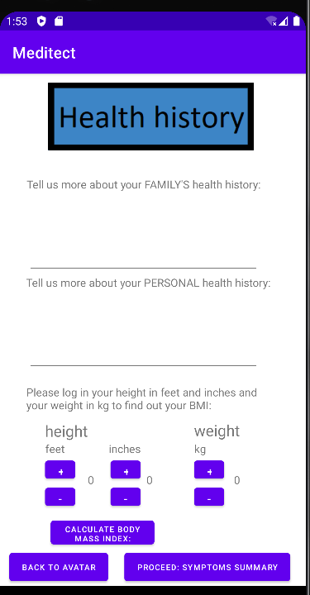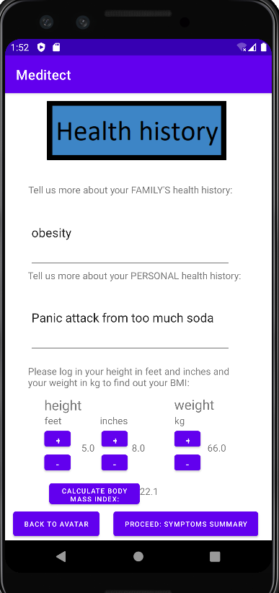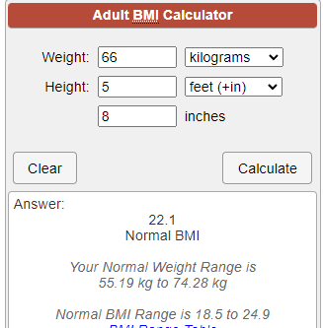

Possible versions of Meditech:  
Health tracker: users can log in their health data such as weight, heigh, systole/diastole heart rate, and other vitals to foresee their health holistically.

Fitness tracker: takes advantage of Android Google Maps API to track the distance of walks everyday, adding more distance of travel as time goes by.